|  |
| --- |
| **Configuration UPS** |

Search UPS 1

Configure UPS Network Card (go to http://<ip>) 2

Configure Date/Time 4

Configure Host Name 6

Configure Notifications 7

Configure Mail Server 7

Configure Recipients 9

Configure Event Actions 10

Configure SNMP 13

Configure SNMP traps 13

Deploy Powerchute OVA 14

Configure Powerchute 22

Test vCenter plugin 36

# Search UPS

Install and run the APC Device IP Configuration Wizard

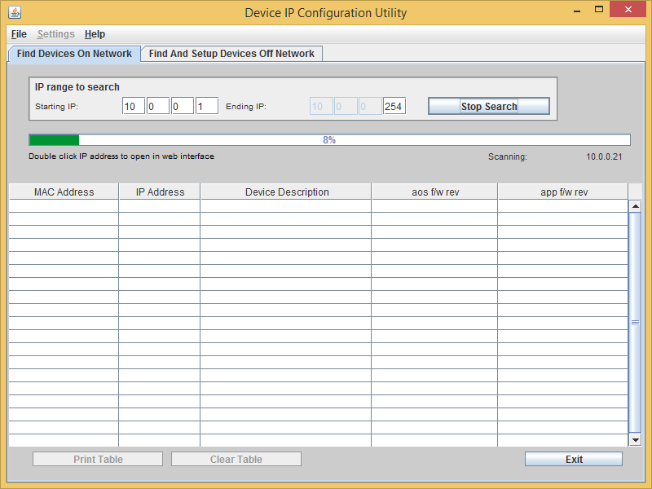

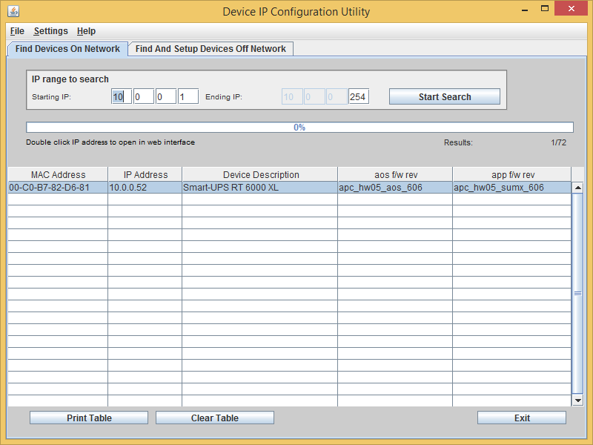

# Configure UPS Network Card (go to http://<ip>)

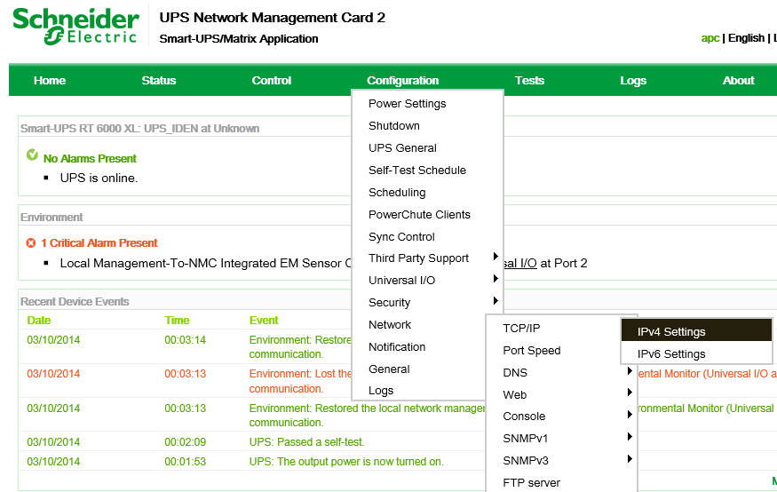

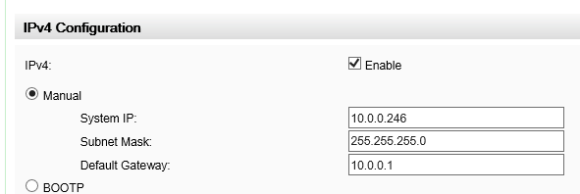

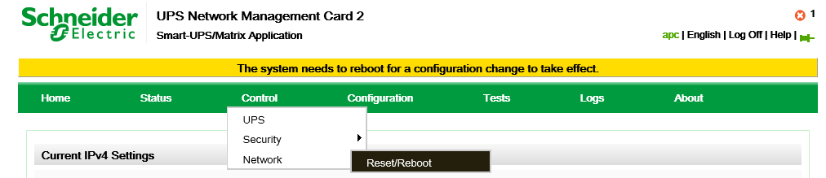

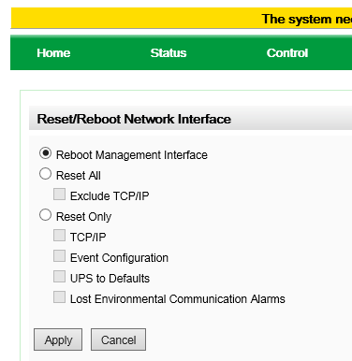

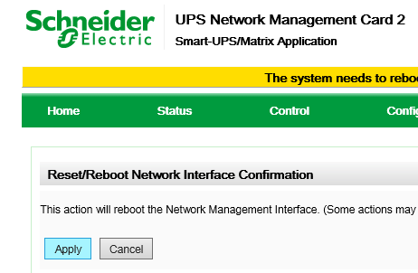

# Configure Date/Time

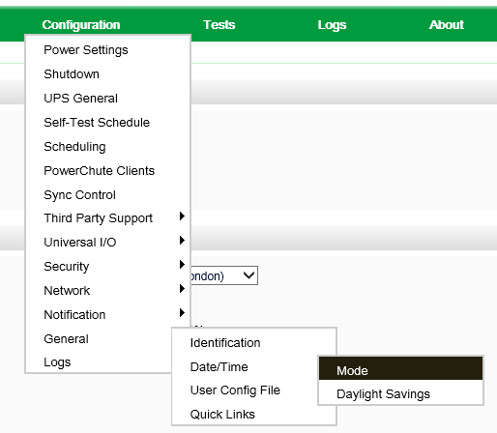

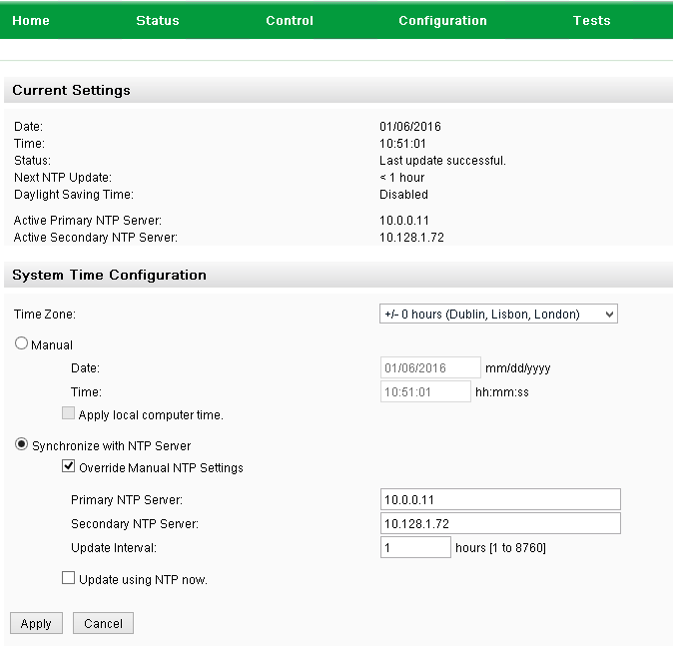

# Configure User

Create the srv_ups user.

Also, don't forget to change the default *apc*-user's password to the correct admin password.

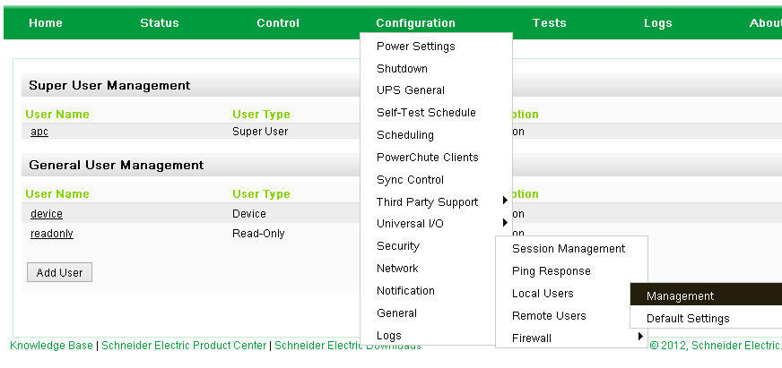

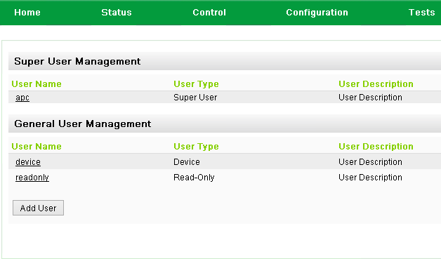

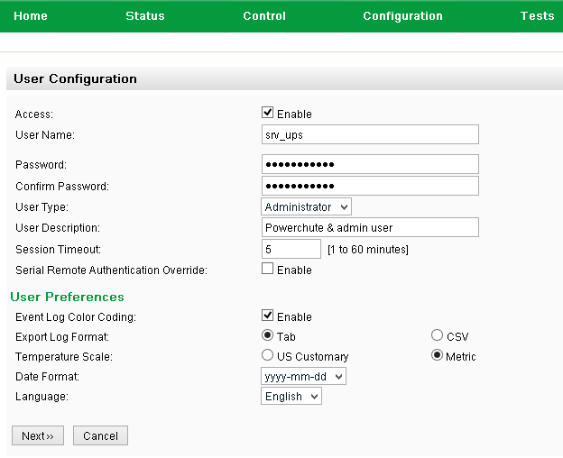

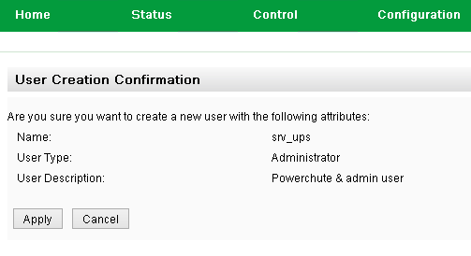

# Configure Host Name

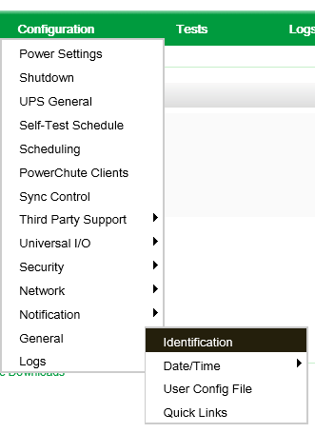

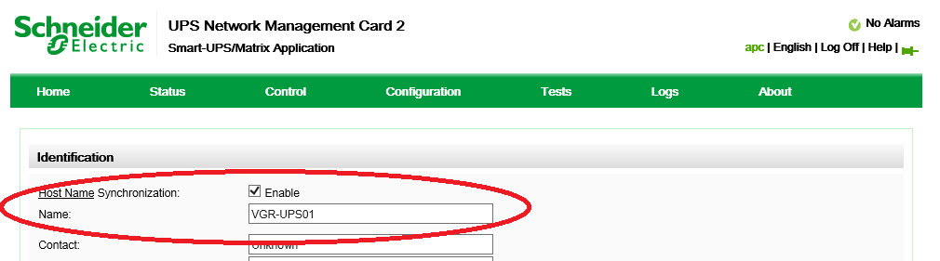

# Upgrade Firmware NMC2 (only applicable for SRT6KXLI)

Copy the file NMC2 v6.5 from \\Jdn-file01\ict_new_standard_sites_vessels\Firmware\Current\Apc SRT6KXLI

to the root of XX-MGMT01

On the XX-MGMT01 go to NMC2 V6.5 and start FW_Upgrade_R2

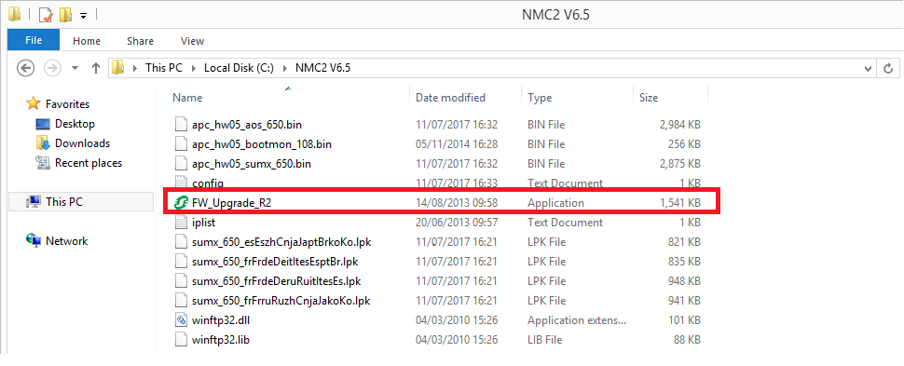

Insert IP Address x.x.x.246 where x is the admin trust range and the srv_ups credentials.

Use the ping button to make sure that the NMC is reachable

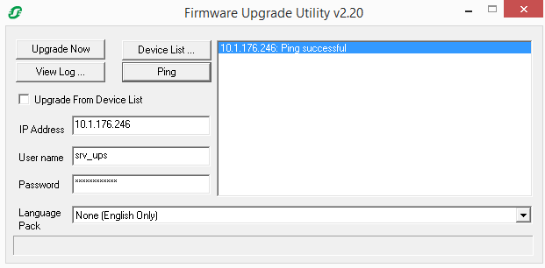

Output should look something like this

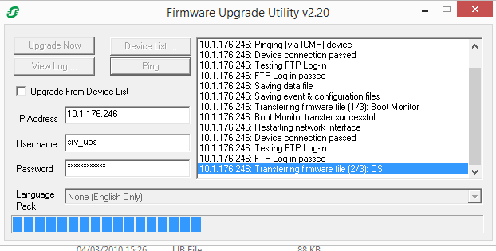

When all is completed you should get the following

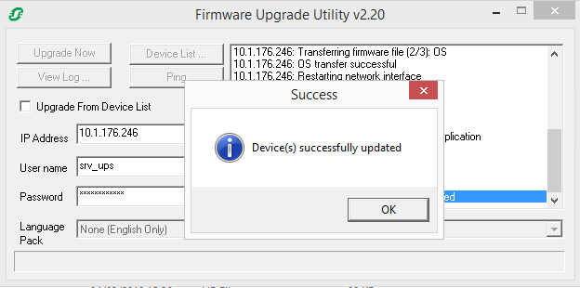

To make sure that it’s been successfull go to http://x.x.x.246

About => Network

The current versions should be as shown on screenshot, if lower then redo the upgrade.

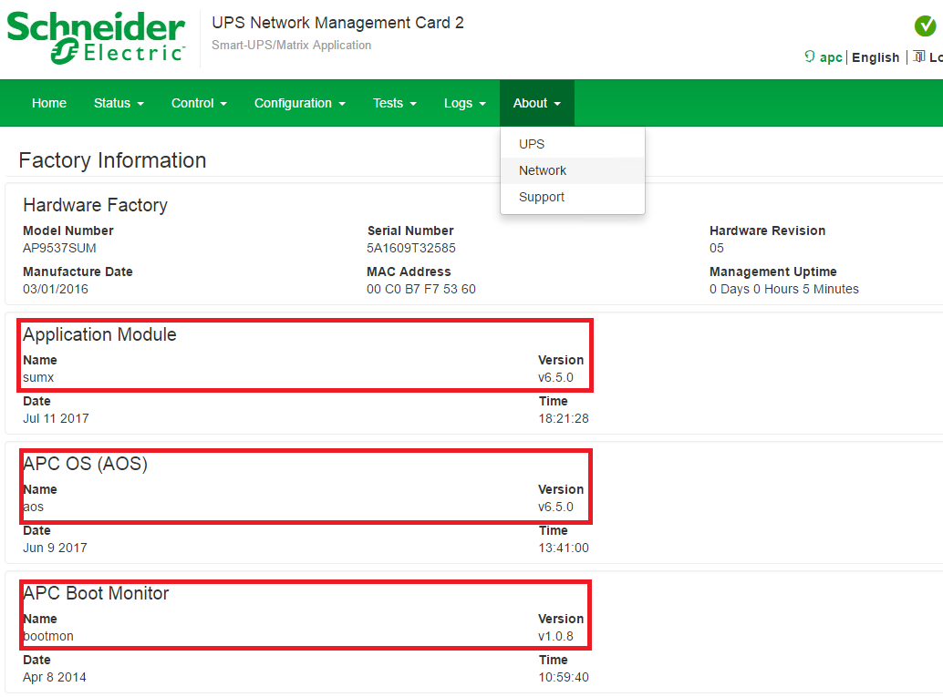

# Configure Notifications

## Configure Mail Server

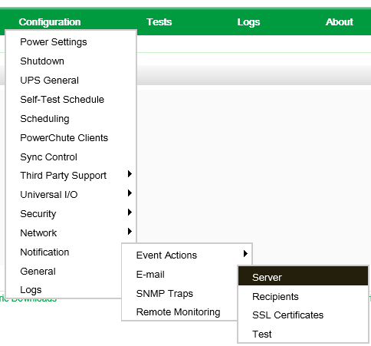

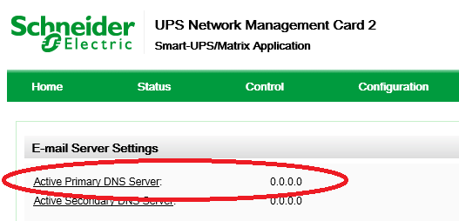

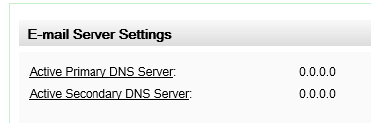

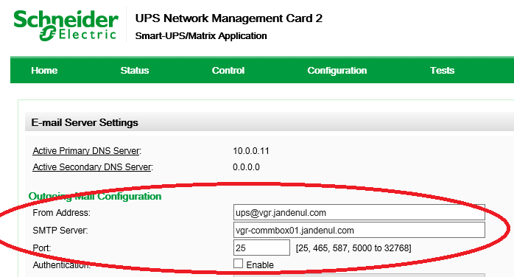

Note: if the domain is not JDN-integrated (which is usually the case for ships), make sure to enter the correct Commbox FQDN (<vessel>-commbox01.<vessel>.situs) instead of @jandenul.com

## Configure Recipients

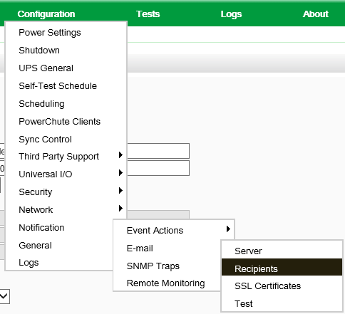

**Recipients:**

Captain, Chief, Elec, ICT-Servicedesk

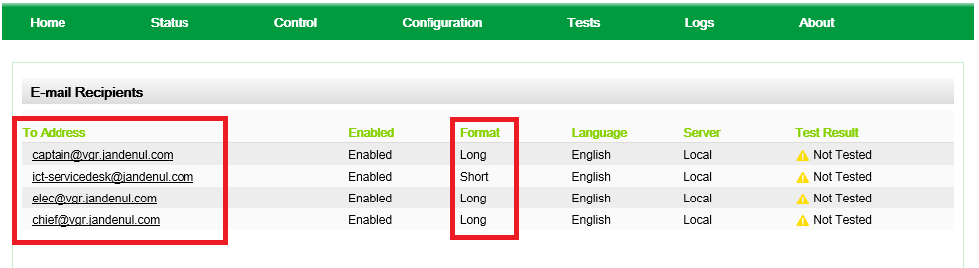

## Configure Event Actions

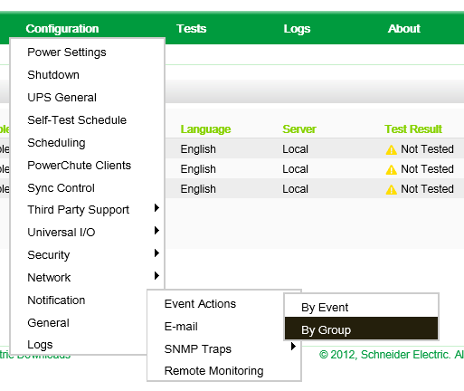

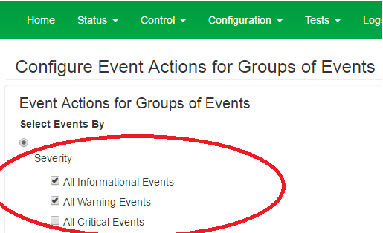

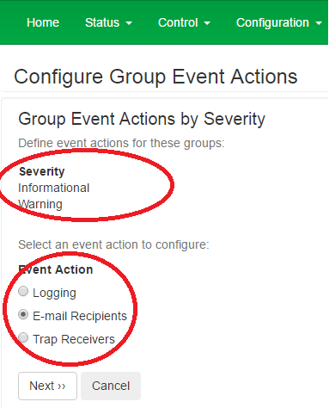

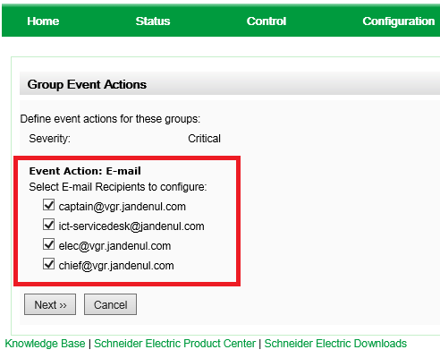

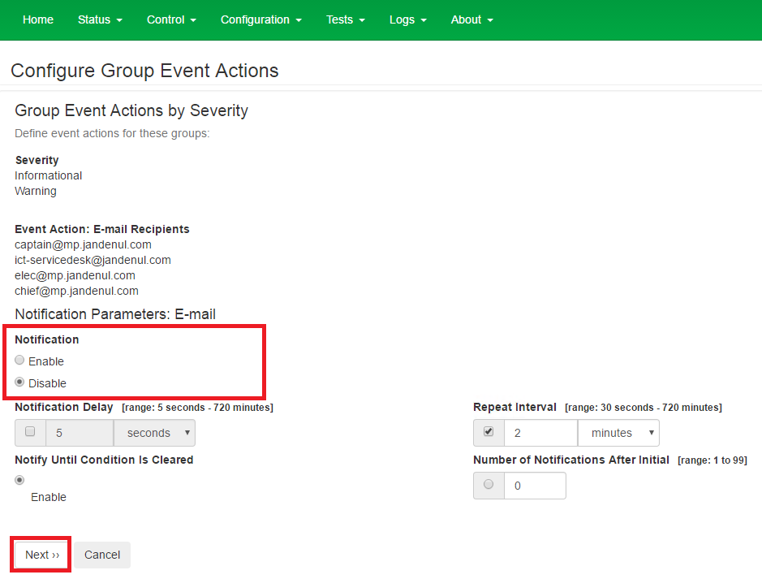

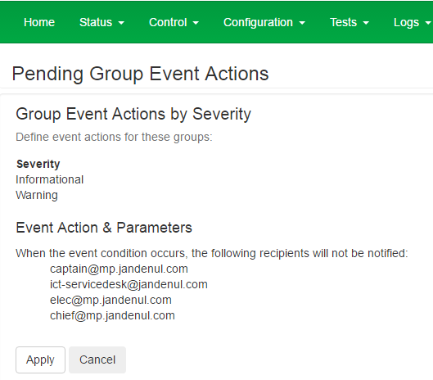

# Configure SNMP

In the top menu, select “Configuration” > “Network” > “SNMPv1” > “Access Control”

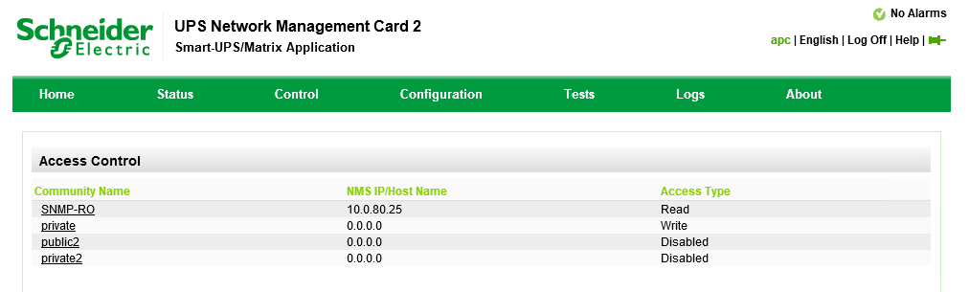

Change “public” to “SNMP-RO” with IP: x.x.x.25 (x.x.x being the admin_trust range)

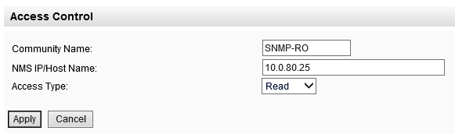

# Configure SNMP traps

In the top menu, select “Configuration” > “Notification” > “SNMP Traps” > “Trap Receivers”

Add Trap Receiver

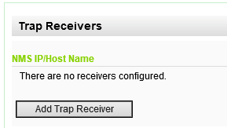

IP: x.x.x.25

Community name (SNMPv1): SNMP-RO

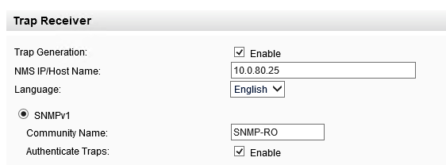

Apply

In the top menu, select “Configuration” > “Notification” > “SNMP Traps” > “Test”

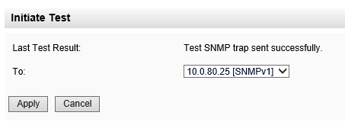

Check the PRTG SNMP Trap Receiver

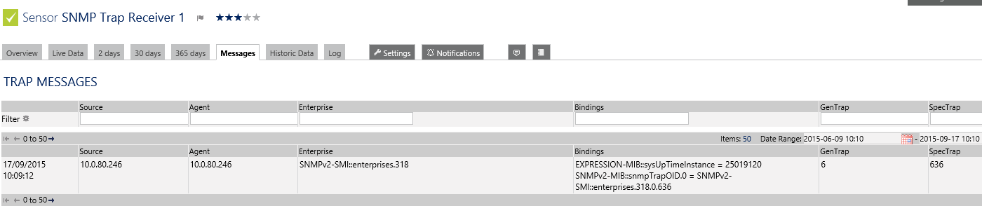

# Change Shutdown Parameters

In the top menu, select “Configuration” > “Shutdown”

Select user Name: SRV_UPS

Authentication Phrase: JanDeNulUPSAuthPhrase

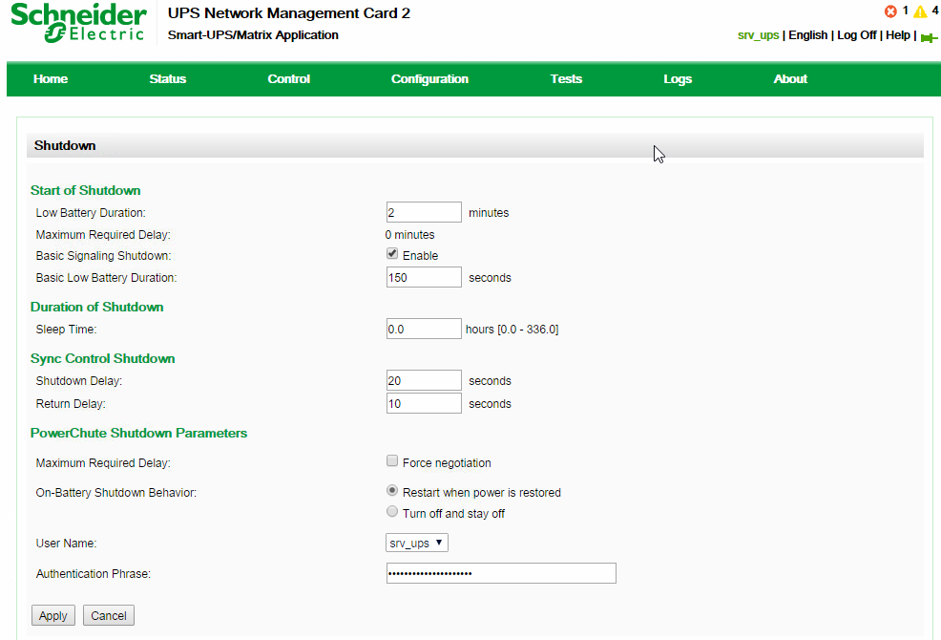

# Deploy Powerchute OVA

If you used the scripted install procedure, the Powerchute OVA will have been deployed. If not, deploy the OVA manually, and assign IP address x.x.x.21 to the Powerchute VM.

# Configure Powerchute

1. Open the console of the newly deployed VM
2. Set the new Linux password (same as Administrator) (WARNING: QWERTY!)

Go to https://<ip>:6547

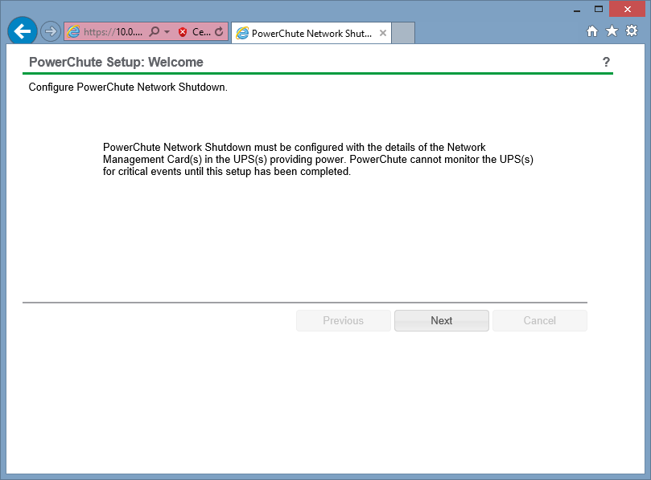

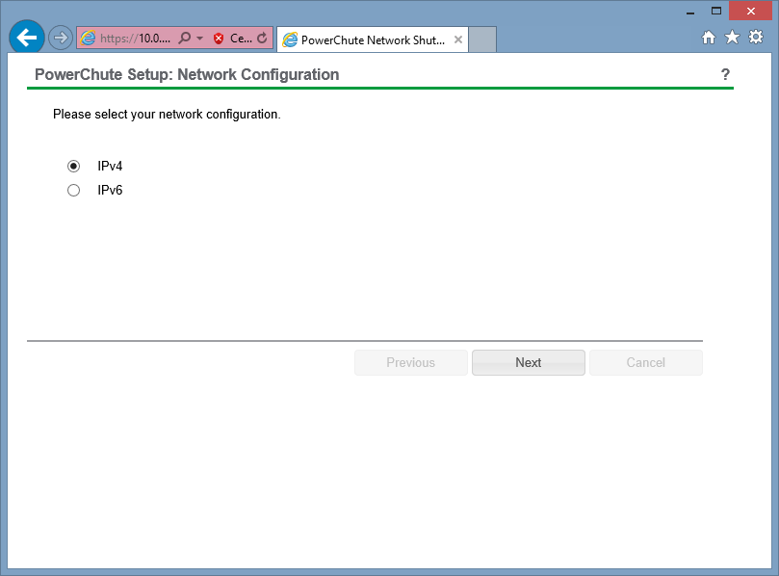

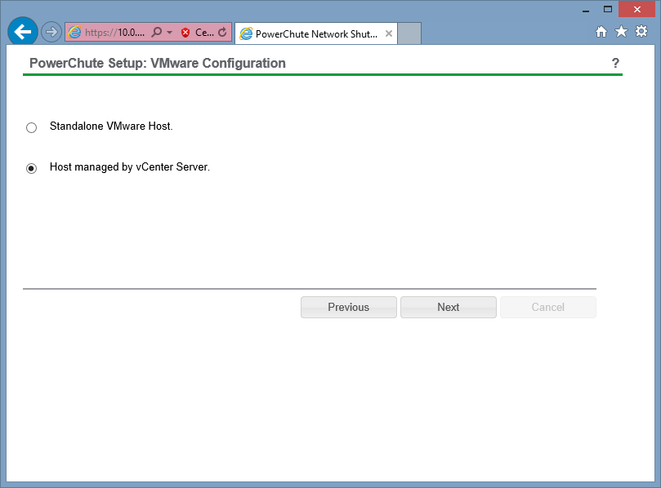

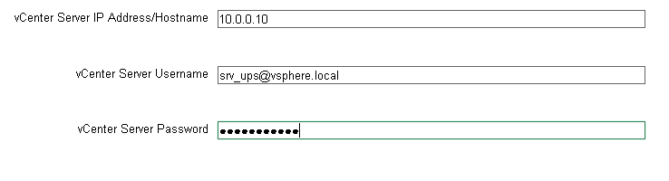

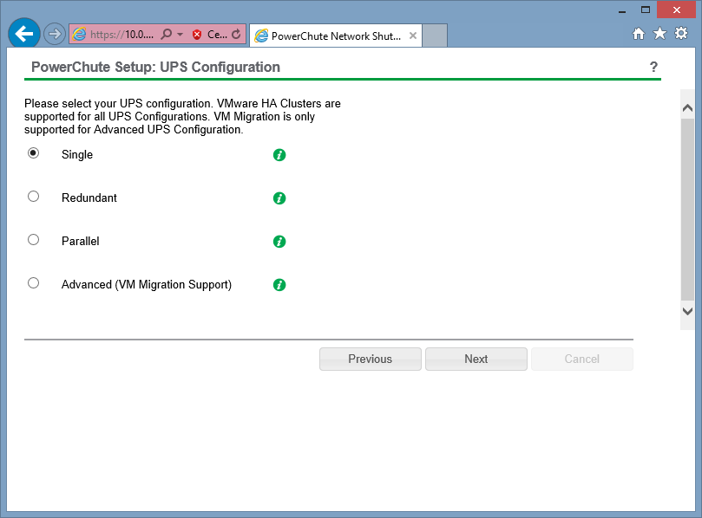

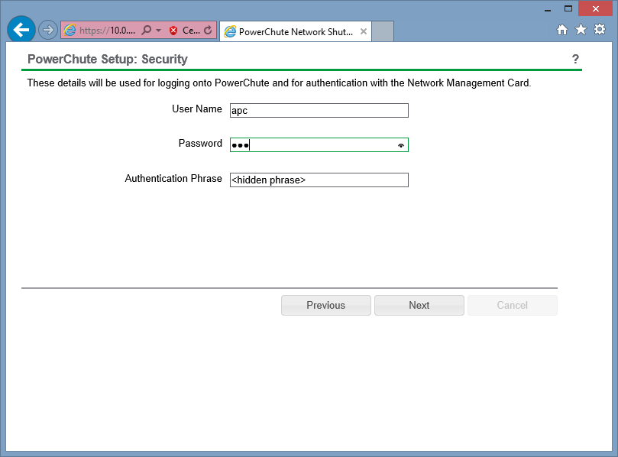

The default user=apc, default password=apc

Obviously do not use the default, but use the srv_ups user you created on the UPS!

Authentication phrase: JanDeNulUPSAuthPhrase

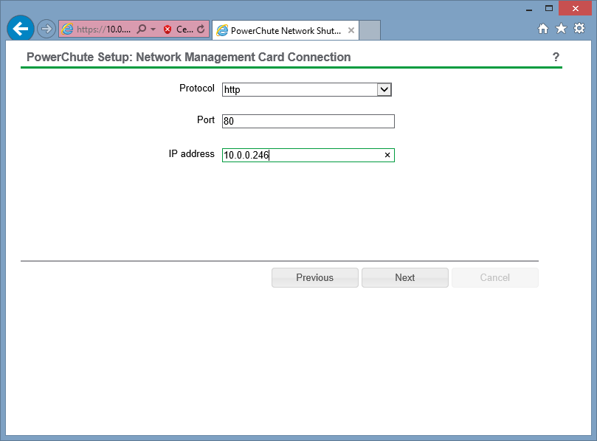

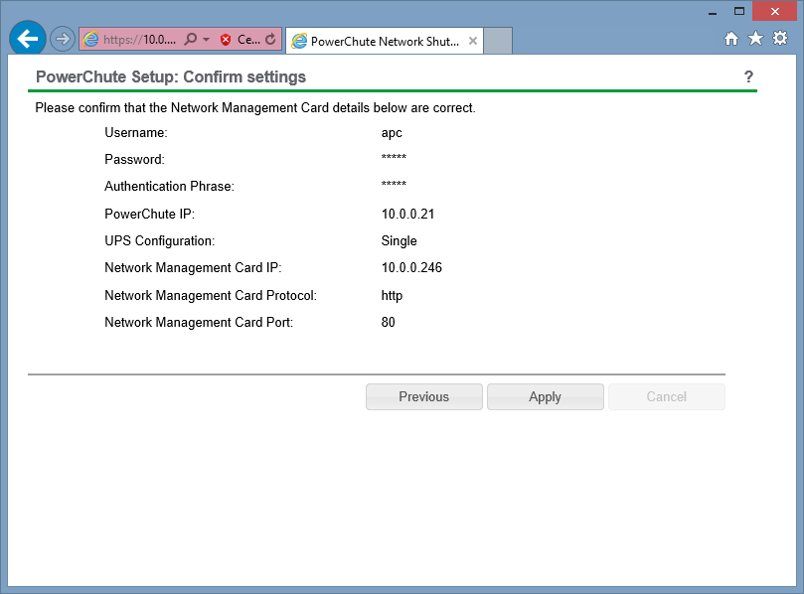

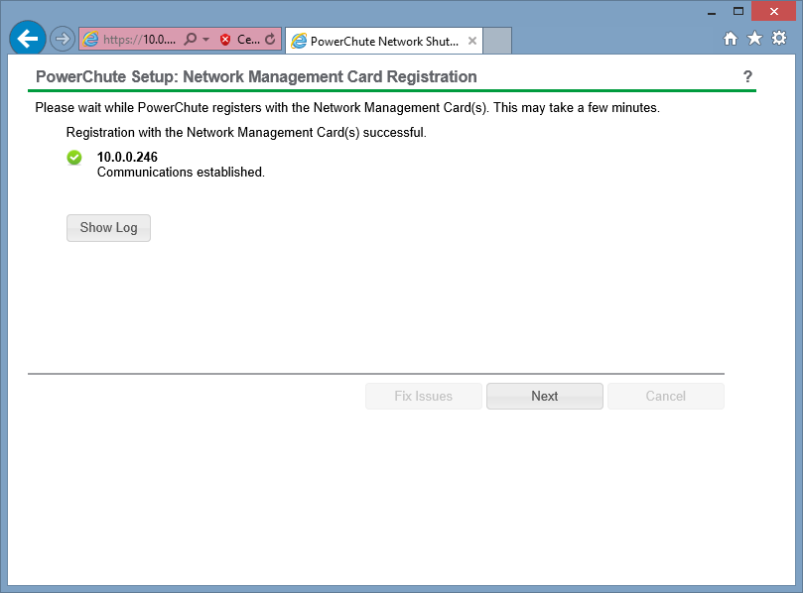

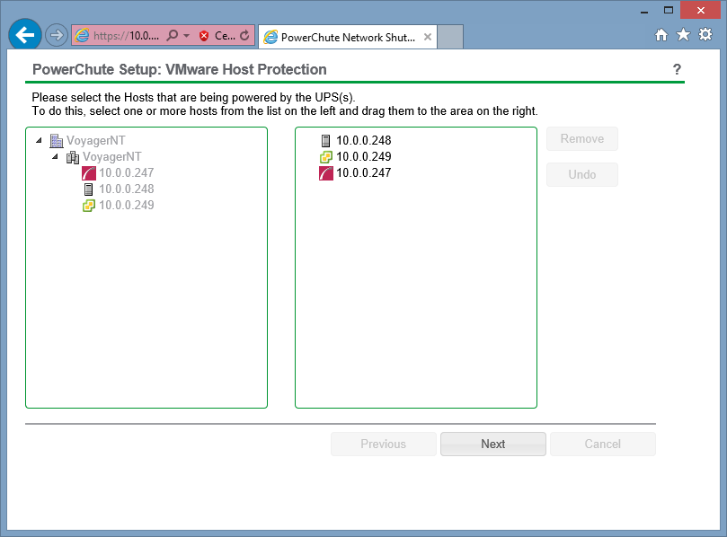

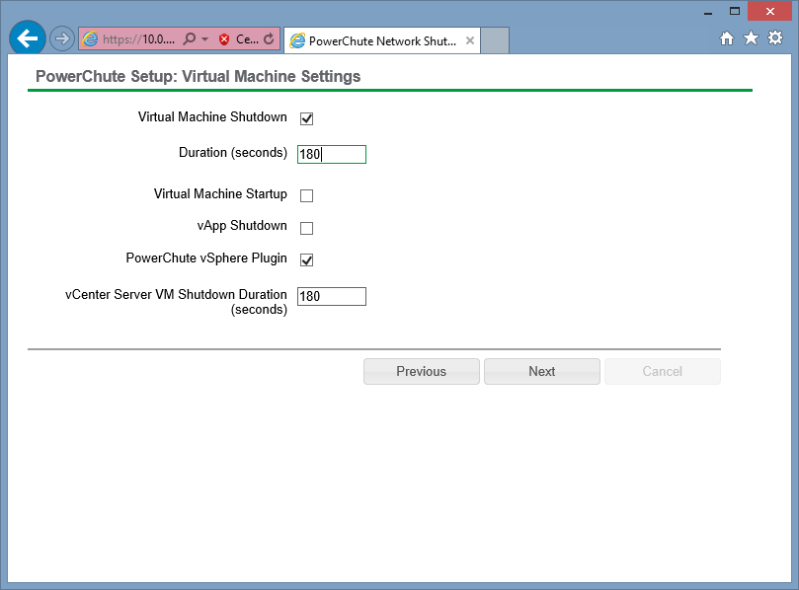

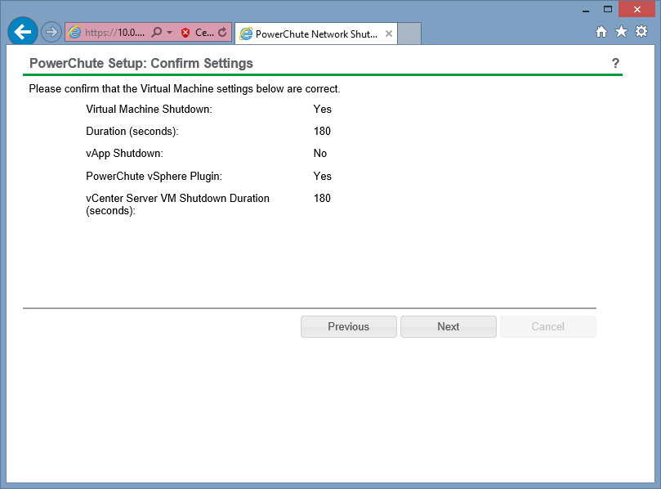

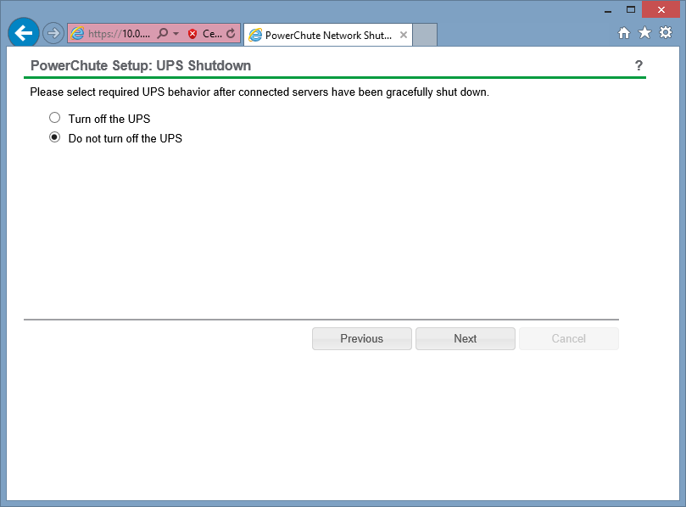

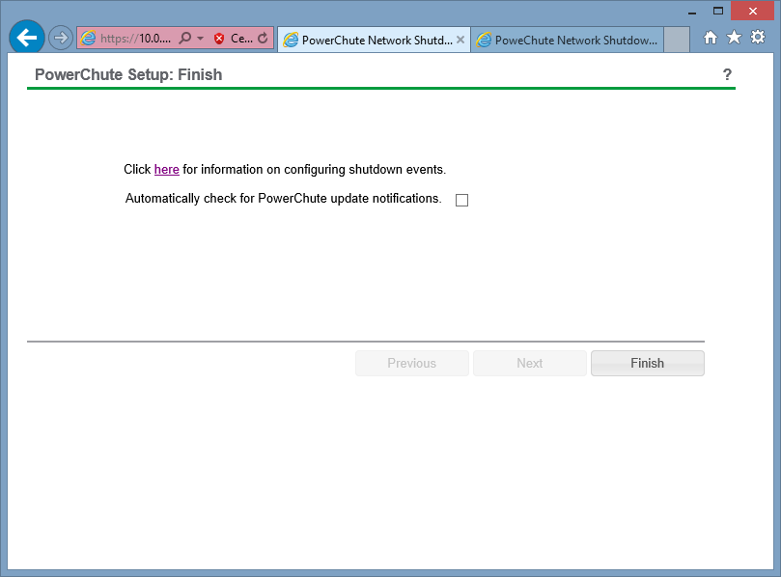

# Test vCenter plugin

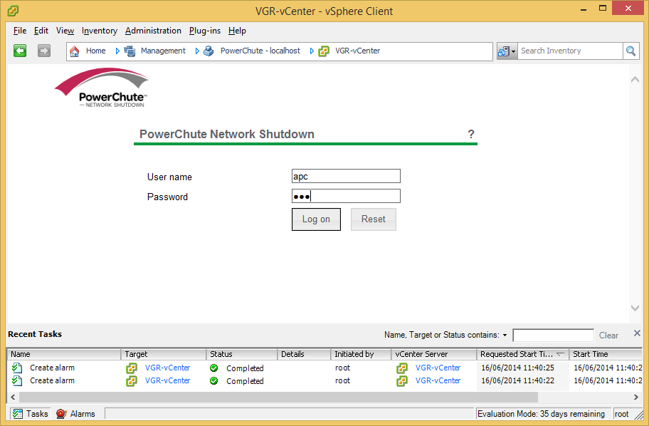

# Runtime calibration

When your UPS is configured, you should perform a runtime calibration.

To start the calibration, go to 'Tests' 🡪 'UPS':

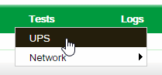

Select 'Runtime calibration' and click 'Apply':

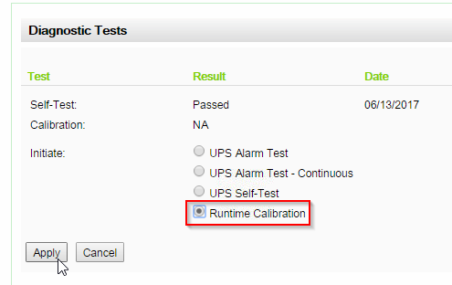

While the calibration is running, the UPS will start beeping, which can be annoying for people in the same room. To switch this off, go into the same menu again or refresh the page and afterwards, select 'Mute UPS Alarm'

